Introduction:
Food safety, an important global public health issue to ensure sound health, refers, to addressing all those hazards, whether chronic or acute, that may make food injurious to the health of the consumer.”⁽¹⁾ Important food hazards include microbial hazards, pesticide residues, misuse of additives, chemical contaminants, including biological toxins and adulteration. Although microbiological contamination and chemical hazards have received most attention, it is recognized that food adulteration and food fraud should not be neglected considering their role in public health.⁽²⁾Food adulteration includes various forms of practices, such as mixing, substituting, concealing the quality of food by mislabeling, putting up decomposed or expired food, and adding toxic substances ⁽³⁾. It is an age-old problem that affects people at all societal strata. The consequences of food adulteration are two-fold for the consumers; the economic loss by paying more for lower quality food items and the health hazards. The health hazards can result from either addition of deleterious substance or removal of a vital component ⁽⁴⁾. Some adulterants may even lead to death ^{(1, 3)}.

Variants: Food contamination can be of various types – intentional, natural, negligent and accidental. Intentional contamination or adulteration is rampant and most dangerous such as argemond seeds in mustard seeds (glaucoma), saw dust in tea (gastric upset), filth in pulses (gastritis), mineral oil in edible oil (Cancer) and lead chromate in turmeric powder (paralysis). Natural contaminants are also injurious such as fluoride in drinking water (teeth mottling), oxalic acid in spinach (renal calculi), polycyclic aromatic in smoked fish (cancer), asbestos in polished rice (cancer) and antibiotics in meat (drug resistance). Lack of knowledge in food processing can lead to negligent food contamination by chemicals (monosodium glutamate in Chinese food – brain damage, coumarine in flavoured food – clotting defect, bromine in vegetable oil – cardiomegaly,sulphite in preservatives – gastritis, and artificial sweetener in sweet meats – cancer). Microbial contamination due to negligence are: Salmonella – typhoid, Shigella – dysentry, Staphylococci – food poisoning, Clostridium botulinum – botulism and aspergillusflavus (aflatoxin) – liver damage. Chernobyl nuclear power explosion in 1986 released large quantities of radioactive particles into the atmosphere, which spread over much of the USSR and Europe leading to accidental food contamination particularly affecting dairy products. Recent trial tested a combinationof sodium benzoate, sunset yellow, carmoisine and tartrazine, all commonly found in sweets and observed significant hyperactivity in children. A senior scientist of ICDDRB said formalin is applied on fish for preservation, calcium carbide on fruits to ripen, urea to whiten the puffed rice and textile dyes to beautify the sweetmeat. Poisonouscolouring agent can damage liver and kidney, calcium carbide may lead to cancer in prostate and lungs and urea is dangerous for kidney. ⁽⁵⁾
We can have an idea of the magnitude to the problem from the tests results by Institute of Public Health. More than half of the food samples tested during 2002 at the Institute of Public Health in Dhaka, were adulterated; among the samples tested, 100% samples of butter oil and banaspatidalda, 90% condensed milk/sweetmeats, 72.3% ghee and honey, and 57.2% cow’s milk were adulterated ⁽⁶⁾. During 2002-2003, Bangladesh Standards and Testing institute (BSTI) had 250 surveillance team/mobile courts that collected 226 food samples from open market for testing, issued 117 show cause notices to manufactures for substandard products, cancelled 45 trade licenses, and undertook 35 legal actions⁽⁷⁾. The mobile court raids against food adulteration intensified in 2005 when electronic and print media featured reports on horrendous food adulteration practices. Sixty-four percent sellers/producers in study in Bangladesh reported using chemicals in their products, although 74% were aware that mixing chemicals with food was harmful to health. They used harmful chemical to make the products more lucrative, increase shelf life , substitute for unavailable natural raw materials, and reduce price of the goods(8). Recently, a growing concern is that the use of prohibited food colors, such as textile dyes in many foods to increase acceptability of food. A detailed picture can be seen from the table 1 & 2 in the following paragraph.
There are several laws and regulations in our country to ensure the standard of food manufacture and sale. Enforcement of food laws, rules and regulations in Bangladesh is a shared responsibility of different ministries and their concerned departments. These are Bangladesh Standards and Testing Institution Ordinance, 1985(XXXVII of 1983) later renamed Bangladesh Standards and Testing Institution (Amendment) Act, 2003. The food samples are analyzed at different government food laboratories. The Consumer Right Protection ordinance 2008 was passed in the parliament on 1 April 2009.

Table 1. Food adulteration detected by Dhaka City Corporation during January 2001- December 2005 ⁽⁸⁾
Year | No. of food items tested | No. of samples tested | No. (%) of samples adulterated
2001  2002  2003  2004  2005 | 37  29  36  33  38 | 563  581  960  674  1193 | 422(75)  453(78)  713(74)  487(72)  763(64)

Table 2: Adulterated food items in Dhaka city,2001 - 2005⁽⁸⁾
Milk and milk products: | Food grains, cereals, and cereal products:
Milk | Rice
Dried milk powder | Wheat
Curd | Lentil/Dal
Icecream | Beson (flour made of peas or chickpeas
Butter | Ata (course wheat flour
Cream | Suzl (semolina)
Ghee (clarified fat) | Lachsasemai (kind of vermicellis)
Rosogolla | Spice:
Kalakand/kalajam
Sandesh | Turmeric powder
Chhana
Kheer | Bakery products:
Mawa | Cake
Malai | Biscuit
Edible oil and oil products: | Fruits, vegetables and miscellaneous products:
Butter oil | Jelly
Soybean oil | Juice
Mustard oil | Sauce
Palm oil | kickles
Coconut oil | Ring chips
Dalda/Banaspati | Honey K  Khair (edible catechu) salt

Adulterants used in different food items of vegetable origin as reported in lay press reports, Dhaka 2006⁽⁸⁾

In case of edible oil it was reported that Soybean oil with Palm oil, chemical, colour, burnt mobil from rail locomotives, burnt oil from electric transformer and mustard oil Chemicals. Food grains and grain products like lentils, mugdal, chola, mosur dal, dabli, Mashkalai, butter dal (lentil types) with toxic colouring agents, imported low quality inedible lentils mixed with textile dye and have fungal growth; less expensive mashkolai dal powdered with champa colour and sold as mugdal. Rice was reported adulterated with urea to make it whiter and in case of dhekichata chal (husked rice) and ata (course flour) it was red toxic colour mixed rice and ata to sell as husked rice, red atta. Muri (puffed rice) with urea fertilizer to make it whiter and puffer. Animal feed wheat, corn found packaged as human food. Semai (vermicllis) produced in unhygienic conditions; Dalda made with rotten potato, cow intestine, low quality palm oil; Vegetables contaminated with Organophophorus compounds and other pesticides; Tomato with Calcium carbide for artificial ripening; Potol (pointed gourd), peas with textile dye; Eggplant with pesticide; chemically coloured dabli as Green peas; Potato with red toxic colour; Mixed spices ( powder) with brick dust, saw dust, chaler kura(dust from outer layer of rice); Turmeric powder with Brick dust, buter dal, khesari dal (lentils), artificial powder, colour; Powder mixed with colour sold as Chilli powder; Chaler kura ( dust from outer layer of rice) mixed with toxic colour sold as coriander powder; Brick dust mixed with toxic colour and powder sold as zeera (cumin) powder; Papaya seed sold as pepper; Salt without iodine. For bakery product it was reported cake adulterated with textile dye, chemicals, inedible date expired ata/maida, fertilizer urea, substandard inedible dalda, rotten eggs; Biscuit with ammonium bicarbonate, sodium cyclamate , fertilizer urea, toxic colouring agents, plam oil, burnt oil, outdated inedible ata /maida; Bread with rotten egg, outdated ata/maida. In case of fruits and fruit products it was reported that calcium carbide are used for artificial ripening of mango, banana, and pineapple; adding chemical colour with Koromcha to sell as cherry; water, flavor and textile dye mixed together to sell as mango juice; sweet pumpkin and colour mixed and sold as lychee juice; imported juice reported as substandard and expired. In case of snacks: Noodles prepared from dhekichata chal, lal ata (coarse wheat flour, red potato; Chanachur, fried in burnt mobil, no potato, imported powder, and colour; Peyaju, Beguni with toxic dye. Chocolate reported to be adulterated with powder, sugar, colour, chemical; Soda for sugar; Sugar syrup for honey; Pickle with inedible ingredients; Jorda ( smokeless tobacco) with wood dust, chemical and Mineral water and drinking water for tap-water, arsenic contaminated , contaminated with bacteria, no mineral.

Here in case of chemical, colour and toxic dye; the chemical nature/ composition not mentioned / specified. The term mobil is a brand name of Plokychlorinated biphenyl (PCB) used as coolant in automobiles and transformers. Items like Cake, Biscuit, Bread, Noodles all found prepared in unhygienic condition.

Adulterants used in different food items of animal origin as reported in lay press reports, Dhaka 2006⁽⁸⁾

Egg, fish, meat, and Meat product
White eggs of farm hens coloured red with textile dye to sell as local hen Egg and Tortoise eggs sold as hen eggs. For fish frauds inject formalin through the gils or dip fishes in water treated with chemicals, such as chlofrofluoro carbon; DDT powder to prevent rotting; add red colour to give fresh look; sell rotten fish. Add DDT to preserve dry fish for longer period. Buffalo, sheep and beef meat sold as mutton; Buffalo meat sold as beef. Halim, a popular item prepared left over bones, intestine.
Sweetmeats and dairy products
Cow’s intestine, dalda mixed with colour, powder to prepare butter; Dalda (hydrogen- Banaspati , toxic chemical, potato smash, cow’s fat, intestine to prepare Ghee. Textile dye is mixed to prepare sweetened curd. They add textile dye named ‘thousand power colour and toxic chimicals; rotten eggs; dalda made with cow’s intestine, saccharin, soybean oil and vegetable oil instead of milk fat; paste of ground rice and sulphuric acid mixed with milk to make posset for sweetmeats. Jilapi(coil-like, juicy sweet) is fried with mobil. Halua is prepared with rotten carrot and lau (bottle gourd) and chemical. Ice-cream is prepard with unsold foul-smelling ice cream, refined and re-packaged, almost no milk, palm oil for soap manufacturing, textile dye, low quality milk powder, sodium cyclamate. Imported milk powder found adulterated, low-quality, date expired and without BSTI approval.
Fast food and restaurant food
Jelly and sauce prepared with toxic coloring agents, chemicals and spirit. Dead chickens are cooked in hotels and restaurants and cooked and raw meat refrigerated together. Shrimp sold rotten and fried and raw fish refrigerate together.
Here in case of chemical, colour and toxic dye; the chemical nature/ composition not mentioned / specified. The term mobil is a brand name of Plokychlorinated biphenyl (PCB) used as coolant in automobiles and transformers. Items like Cake, Biscuit, Bread, Noodles all found prepared in unhygienic condition.
OBJECTIVES OF THE STUDY:
General Objective:
- To know knowledge & practice of rural people about food adulteration in Swarashati villages of Golapgonj Upozila.

Specific Objectives:
- To see knowledge of common food items are being adulterated.
- To know the common adulterants used.
- To have an idea about the specific adulterants with which common food items are usually adulterated.
- To see the knowledge about the deleterious effects of adulterants.
- To determine the protective measures they take to make food items safer.
- To obtain socio-economic characteristic of the respondents.

METHODOLOGY:

- Type of study: Cross sectional type of descriptive study.
- Study place: Swarashati village of Golapgonj upozila, Sylhet.
- Study population: All the people of Swarashati village who are at least 18 years of age.
- Sample size: 88
- Sampling technique: Non-probability purposive sampling was done.
- Data collection instrument: A semi-structured questionnaire was used to collect data.
- Data collection technique: Data was collected from the respondents by the researchers (students) themselves by face to face interview.
- Data analysis: On completion of data collection, data were tabulated after checking & verification. Data were analysed by simple statistical method using a computer.

RESULT
Table No. 2: -Distribution of respondents according to age.

Age | Frequency | Percentage
16-20 | 17 | 19.31
21-25 | 26 | 29.55
26-30 | 20 | 22.73
31 or above | 25 | 28.41
Total | 88 | 100.00

This table shows that 19.31% respondents are of the age group 16-20 years, 29.55%
are of 21-25 years group, 22.73% are of 27-30 years group and 28.41% aged 31 or more.

Table No. 1:-Distribution of respondents according to sex.

Sex | Frequency | Percentage
Male | 13 | 14.77
Female | 75 | 85.23
Total | 88 | 100.00

This table shows that male respondents are 14.77% and female are 85.23%.

Table No. 3: -Distribution of respondents according to educational qualification.

Educational Qualification | Frequency | Percentage
Primary | 61 | 69.32
SSC | 24 | 27.27
HSC and above | 03 | 03.41
Total | 88 | 100.00

This table shows that 69.32% respondents studied up to primary level, 27.27% up to SSC
and 3.41% up to HSC or above.

Table no. 4: - Occupation of the respondents.
Occupation | Frequency |  | Percentage
Housewife | 68 |  | 77.27
Service holder | 03 |  | 03.41
Businessman | 07 |  | 07.95
Teacher | 02 |  | 02.27
Farmer | 01 |  | 01.14
Student | 01 |  | 01.14
Others | 06 |  | 06.82
Total |  | 88 | 100.00
The table shows that 77.27% respondents are housewife, service holder 3.41%,
businessman 7.95%, teacher 2.27%, farmer 1.14%, student 1.14% and 6.82% are engaged
in other occupations.
Table no: 5- Distribution of respondents according to number of family members.
Family members | Frequency | Percentage
1- 5 | 28 | 31.82
6 -10 | 55 | 62.50
11 and above | 05 | 05.68
Total | 88 | 100.00
This table shows that 31.82% families have 1- 5 members in their family, 62.5% have 6-10 and 5.68% have 11-15 members in their family.

Table No.: 6 - Distribution of respondents according to number of children.
Number of children | Frequency | Percentage
0 | 16 | 18.18
1 | 15 | 17.05
2 | 17 | 19.31
3 | 19 | 21.60
4 and above | 21 | 23.86
Total | 88 | 100.00

This table shows that 18.18% respondents have no children, 17.05% respondents have 1 child, 19.31% respondents have 2 children, 21.60% respondents have 3 children and 23.86% respondents have 4 or more children.

Table No.: 7 - Distribution of respondents according to their monthly family income.
Monthly income | Frequency | Percentage
<4000 | 13 | 14.77
4000-6000 | 14 | 15.91
6001-8000 | 18 | 20.45
8001-10,000 | 06 | 06.82
>10,000 | 37 | 42.05
Total | 88 | 100.00

This table shows that 14.77% respondents earn <4000 taka, 15.91% respondents earn 4000-6000 taka, 20.45% respondents earn 6001-8000 taka, 06.82% respondents earn 8001-10,000 taka and 42.05% respondents earn >10,000 taka.

Table No.: 8 -Distribution of respondents according to knowledge about when a food item is said to be adulterated.

Knowledge | Frequency | Percentage
Rotten food | 53 | 60.23
Addition of harmful substance | 29 | 32.95
Low quality food | 07 | 07.95
Addition of Chemical | 28 | 31.82
Artificial color | 21 | 23.86
No idea | 08 | 09.09
Total | 146 | --

This table shows that 60.23% respondents said that food is said to be adulterated when it is rotten, 32.95% said by anything added which is harmful, low quality food 7.95%, by chemical 31.82%, by artificial color 23.86%, do not have any idea 9.09%.

Table No.: 9 -Distribution of respondents according to knowledge of food items that are usually adulterated.

Knowledge | Frequency | Percentage
Oil | 17 | 19.32
Fish | 61 | 69.32
Vegetables | 55 | 62.50
Fruits | 58 | 65.91
Spices | 15 | 17.05
Milk | 19 | 21.59
Puffed rice | 04 | 04.55
Juice | 12 | 13.64
Sweetmeat | 12 | 13.64
Butter | 02 | 02.27
Common Salt | 07 | 07.95
Fast food | 08 | 09.09
Bakery food | 16 | 18.18
No idea | 01 | 01.14
Others | 03 | 03.41
Total | 290 | --

This table shows that the common food items those are being adulterated and 19.32% said it is oil, said fish 69.32%, said vegetables 62.50%, fruits 65.91%, spices 17.05%, milk 21.59%, puffed rice 04.55%, juice 13.64%, sweetmeat 13.64%, butter 02.27%, common salt 07.95%, fast food 09.09%, bakery food 18.18%, have no idea 01.14% and 03.41% said other food items.

Fig. No. : 1 – Distribution of respondents according to knowledge about usually used adulterants in food.

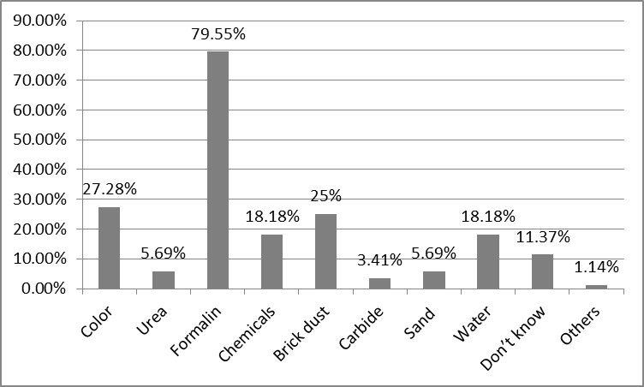

This simple bar diagram shows that the common adulterants those are being used and 27.28% adulterants are color, 05.69% adulterants are urea, 79.55% adulterants are formalin, 18.18% adulterants are chemicals, 25.00% adulterants are brick dust, 03.41% adulterants are carbide, 05.69% adulterants are soil, 18.18% adulterants are water, 11.37% adulterants don’t know, 01.14% adulterants are others.

Food items | Formalin | Colour | Excess fertilizer | Insecticide | Carbide | DDT | Don’t Know | Total
Fish | 72  (81.82%) | 3  (3.41%) |  |  |  |  | 13  (14.70%) | 88  (100%)
Vegetable |  | 1  (1.14%) | 37  (42.04%) | 28  (31.82%) |  |  | 22  (25.00%) | 88  (100%)
Fruit | 62  (70.45%) | 11  (12.50%) |  |  | 8  (9.09%) |  | 7  (7.96%) | 88  (100%)
Shutki |  | 2  (2.27%) |  |  |  | 9  (10.23%) | 77  (87.50%) | 88  (100%)
Table No.:10 – Respondents knowledge about common adulterants.

This table shows that the respondents said fish is adulterated with formalin, 81.82%, colour, 3.41%, don’t know 14.70%; Vegetable with colour 1.14%, don’t know 25.00%; Fruits with Formalin 70.45%, colour 12.50%, don’t know 7.96%; Shutki with colour 2.27%, DDT 10.23% AND don’t know 87.50%;

Table No.:11 – Respondent’s opinion about the adulterants used in spice and bakery products.

Food items | Colour | Wood dust | Brick dust | Harmful cheap materials | Burnt  Engine Oil | Don’t Know | Total
Spice | 17  (19.32%) | 6  (6.82%) | 35  (39.77%) |  |  | 30  (34.09%) | 88  (100%)
Bakery food | 56  (63.64%) |  |  | 30  (34.09%) |  | 2  (2.27%) | 88  (100%)
Singara, Somucha, Chanachur | 7  (7.95%) |  |  |  | 17  (19.32%) | 64  (72.73%) | 88  (100%)

This table shows that the respondents said Spice is adulterated with colour 19.32%, wood dust 6.82%, brick dust 39.77%, don’t know 34.09%; Bakery food with colour 63.64%, harmful cheap materials 34.09%, and don’t know 2.27%; Singara, Somocha, chanachur with colour 7.95%, burnt engine oil 19.32% and don’t know 72.73%.

Fig. No. : 2 – Distribution of Respondents according to the knowledge of harmful effects of food adulteration on health.
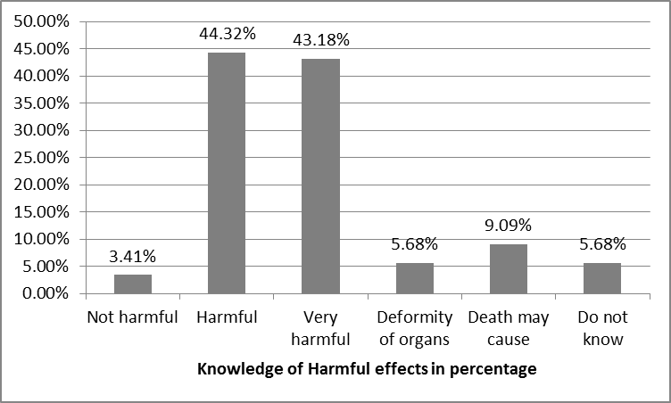

This simple bar diagram shows that 03.41% respondents said food adulteration is not harmful, 44.32% said harmful, 43.18% said very harmful, 05.68% said deformity in organs can occur, 09.09% said death may cause and 05.68% do not know.

Table no.:-12- Distribution of respondents about the queries they while buying open foods.
Qualities | Frequency | Percentage (%)
Colour | 17 | 19.32
Freshness | 55 | 62.50
Smell | 09 | 10.23
Cleanliness | 29 | 32.95
Price | 02 | 02.27
No idea | 09 | 10.23
Total | 121 | --
The table shows that 19.32% of respondents buy open foods observing its colour, 62.50% of respondents observing its freshness, 10.23% of respondents check its smell, 32.95% of respondents observe it’s cleanliness, 02.27% of respondents consider the price and 10.23% respondents have no idea of checking food while buying open foods.

Fig. No. : 3- Distribution of respondents about allowing their children to eat chocholates, icecream etc.

 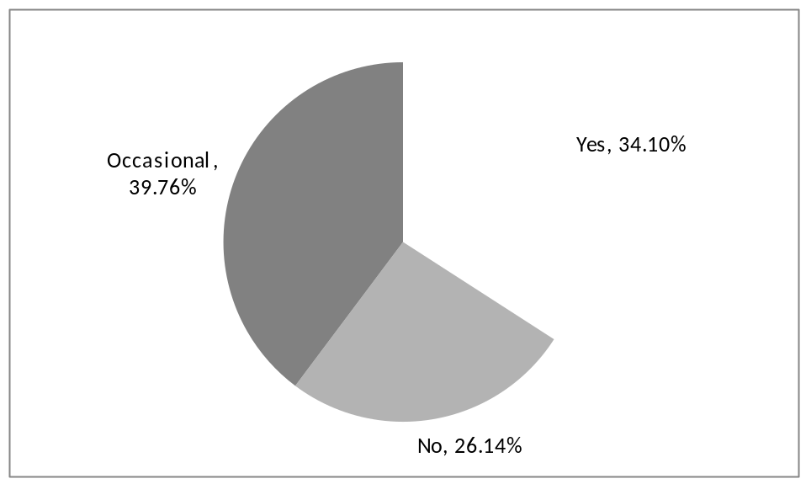

The pie diagram shows that 34.10% of respondents allow, 26.14% don’t allow and 39.75% of respondents allow their children occasionally.

Table no: 13- Distribution of respondents according to their knowledge about the harmful effects of adulterated food on children’s mental and physical development
Answer of respondents | Frequency | Percentage (%)
Yes | 79 | 89.77
No | 9 | 10.23
Total | 88 | 100.00

This table shows that 89.77% respondents know about the harmful effects of adulterated food on children’s mental and physical development and 10.23% respondents don’t know about the harmful effects of adulterated food on children’s mental and physical development.
Table no: 14- Distribution of respondents according to their knowledge about the testing of iodised salt
Answer of respondents | Frequency | Percentage (%)
Knows well | 16 | 18.18
Knows wrong | 4 | 4.55
Doesn’t know | 68 | 77.27
Total | 88 | 100.00

The table shows that 18.18% respondents know well about the testing of iodised salt, 4.55% respondents know wrongly about the test of iodised salt and 77.27% respondents don’t know about the test of iodised salt.
Fig. No. : 4 - Distribution of respondents according to knowledge of inspecting adulterated fish with formalin.

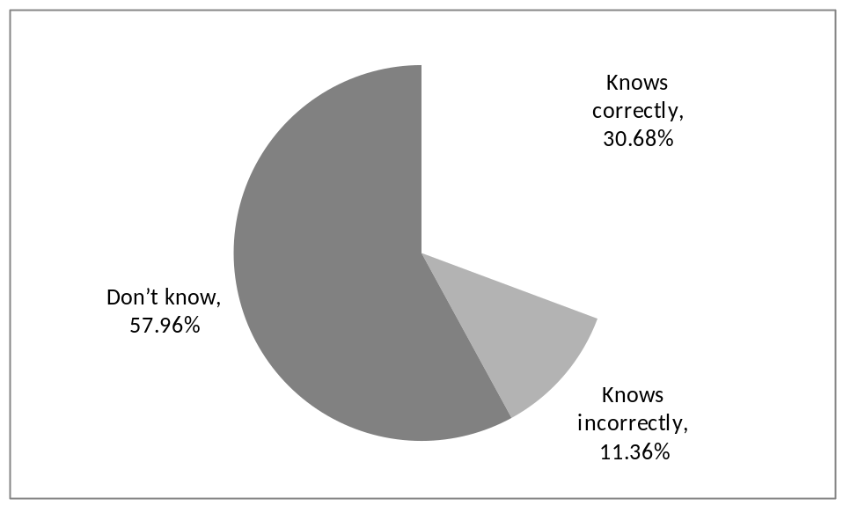

This table shows that 30.68% respondents know correctly,11.36% know incorrectly,57.96% don’t know whether the fish is contaminated with formalin or not.

Table No.:15-Distribution of respondents according to the action(s) they take with adulterated food.

Action | Frequency | Percentage
Inform sanitary inspector | 00 | 00.00
Throw | 62 | 70.45
Eat | 21 | 23.86
Return | 12 | 13.64
Others | 02 | 02.27
Total | 97 | --

This table shows that none of the respondents inform sanitary inspector, 70.45% throw these, 23.86% eat these, 13.64% return these, and 02.27% do other things.

Fig. No. :5 - Distribution of respondents according to source from which they get knowledge about food adulteration.

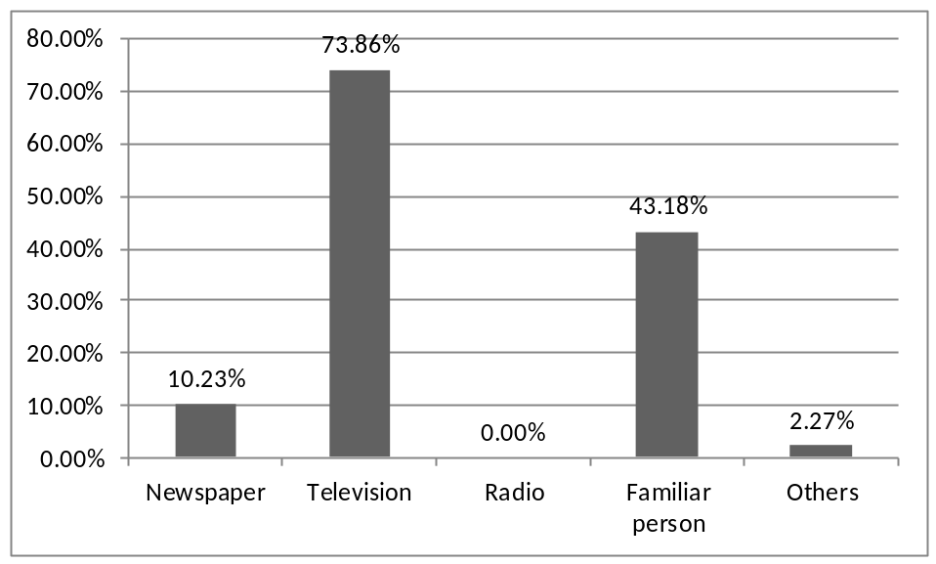

This simple bar diagram shows that respondents got the information from Newspaper 10.23%, from Television 73.86%, known person 43.18%, none from Radio and others 2.27%.

Table no. : 16-Distribution of respondents according to who can be thought or made aware about the procedure of detection to prevent food adulteration.
Person | Frequency | Percentage (%)
Male | 04 | 04.55
Female | 03 | 03.41
Male and female | 74 | 84.09
Don’t know | 07 | 07.95
Total | 88 | 100.00

This table shows that 4.65% respondents said male should be educated, 3.48% said female, 86.06% said both male and female and 5.81% don’t know.

Table no. :17- Distribution of respondents according to how can aware the children about food adulteration
Person | Frequency | Percentage (%)
Parents and relatives | 51 | 57.95
School teacher | 46 | 52.27
others | 03 | 03.41
Total | 100

This table shows that 100% respondents are of parents and relatives 57.95%, school teacher 52.27% and others 03.41%

DISCUSSION
Food safety is an important public health issue. Day by day it is getting worst dimensions with various types of health impacts at all levels of the society. Underdeveloped and developing countries with low socioeconomic condition and lack of education employing a alarming situation. This cross sectional descriptive study was carried out to find out the knowledge and practice regarding food adulteration of rural people. Eighty eight respondents were interviewed.

Socio-demographic information of the respondent
In this study regarding the sex of the respondents, majority are female, 85.23% and only 14.77% are male. This may be due to the fact that we interviewed the respondents in evening time when the male were engaged in their daily activities outside their residence.
(Ref.Table No. – 1)

Regarding the age of the respondents 19.31% respondents are of the age group 16-20 years, 29.55% are of 21-25 years group, 22.73% are of 27-30 years group and 28.41% aged 31 or more. It is seen that 69.32% respondents studied up to primary level, 27.27% up to SSC and 3.41% up to the level of HSC or above. (Ref.Table No. – 2 &3)

We recorded the occupations of the respondents and found77.27% respondents are housewives, 3.41% are service holders, 7.95% are businessmen, 2.27%teachers, 1.14% farmer, 1.14% respondents 6.82% are engaged in other occupations. In relation to total numbers of family members; 31.82% families have 1- 5 members in their family, 62.5% have 6-10 and 5.68% have 11-15 members in their family. (Ref. Table No. – 4 &5)

Regarding the number of children the respondents have; 18.18% respondents have no child, 17.05% respondents have 1 child, 19.31% respondents have 2 children, 21.60% respondents have 3 children and 23.86% respondents have 4 or more children. So, it is seen that already about half; 45.46% families not conforming to 2 child norm family. We also had an idea about the financial status of the respondents and found 14.77% respondents earn <4000 taka, 15.91% respondents earn 4000-6000 taka, 20.45% respondents earn 6001-8000 taka, 06.82% respondents earn 8001-10,000 taka and 42.05% respondents earn >10,000 taka.So, about half; 48.85% of the respondent have a monthly income in excess of 8000 taka per month.(Ref. Table No. – 6 &7)

Knowledge of the respondents regarding food adulteration

More than half of the respondents; 60.23% said that food is said to be adulterated when it is rotten, 32.95% said by anything added which is harmful, low quality food 7.95%, by chemical 31.82%, by artificial color 23.86%, do not have any idea 9.09%. In a study conducted in 2006 in Dhaka city; among the respondents, 23% said rotten food, 18% said anything added which is harmful, 16% said substandard food, 15% said chemicals, 12% said artificial colour, did not know 13%. So, the knowledge found far better than the consumers of Dhaka city. It is to be mentioned here that the time gap is 10 years. So this improvement in knowledge may be due to the fact that for the last few years Government and different organisations are very much concerned in educating the people in this regard. (Table – 8)

Regarding common food items those are being adulterated; 19.32% respondents said it is oil, 69.32% said fish, 62.50% said vegetables, 65.91% said fruits, 17.05% said spices, 21.59% said milk, 04.55% said puffed rice, 13.64% said juice, 13.64% sweetmeat, 02.27% said butter, 07.95% common salt, 09.09% fast food, 18.18% bakery food , 01.14% have no idea and 03.41% said other food items. In this regard in the same study mentioned before conducted in 2006 in Dhaka city the respondents said; oil 43%, fish 33%, vegetables 31%, fruits 19%, spices 18%, milk 15%, puffed rice 9%, juice 7%, sweetmeat 6%, butter 3%, common salt 3%, fast food 2%, bakery food 1%, did not know 4%. Again the respondents showed better knowledge in our study findings might be due to the same reason mentioned earlier in the previous paragraph. (Ref. Table – 9)

Regarding the common food adulterants those are being used, the respondents said; 27.28% said adulterants are color, 05.69% said adulterants are urea, 79.55% said adulterants are formalin, 18.18% said adulterants are chemicals, 25.00% said adulterants are brick dust, 03.41% said adulterants are carbide, 05.69% said adulterants are soil, 18.18% said adulterants are water, 11.37% don’t know adulterant materials, 01.14% said other adulterants not in the list. In the study conducted in 2006 in Dhaka city mentioned earlier; among the respondents of Dhaka city said colour 40%, urea 22%, formalin 21%, chemicals 17%, brick dusts 2%, carbide 1%, sand 1%, water 1%, 11.37% don’t know adulterant materials, 01.14% mentioned other adulterants. This study shows that the respondents are more aware in much more numbers than of the Dhaka city in 2006 regarding formalin, chemicals, brick dust, sand, carbide etc. (Ref. Fig. – 1)

Fish adulteration is a worst concern in Bangladesh especially in cities. In this regard the respondents said that fish is adulterated with formalin 81.82%, with colour 3.41%, don’t know 14.70%. For vegetable with colour 1.14%, don’t know 25.00%; Fruits with Formalin 70.45%, colour12.50%, don’t know 7.96%; Shutki with colour2.27%, DDT 10.23% and don’t know 87.50%. Spices are costly and amongst the common items that are being adulterated. The respondents said Spice is adulterated with colour19.32%, with wood dust 6.82%, with brick dust 39.77%, don’t know 34.09%; Bakery food with colour 63.64%, with harmful cheap materials 34.09%, and don’t know 2.27%. Singara, Somocha, chanachur with colour 7.95%, with burnt engine oil 19.32% and don’t know 72.73%. Knowledge about the deleterious effects of adulterated food 03.41% respondents said that adulterated food is not harmful, 44.32% said harmful, 43.18% said very harmful, 05.68% said deformity of organs can occur, 09.09% said death may cause and 05.68% do not know. (Ref. Table – 10, 11 & Fig. - 2)

Steps taken by the respondents to avoid harmful effects of adulterated food.
We saw the how consumers buy food items while adulteration is a common practice. It is revealed that 19.32% of respondents buy open foods observing its colour, 62.50% of respondents observing its freshness, 10.23% of respondents check its smell, 32.95% of respondents observe it’s cleanliness, 02.27% of respondents consider the price and 10.23% respondents have no idea of checking food while buying open foods. Children are very much vulnerable to food adulteration as bakery products are usually preferred by the children as tiffin in the school and as snakes in the home as well. More than third of the respondents; 34.10% said they allow fast food and bakery food to their children, 26.14% don’t allow and 39.75% of respondents allow their children occasionally. In this regard it is seen that 89.77% respondents know about the harmful effects of adulterated food on children’s mental and physical development and 10.23% respondents don’t know about the harmful effects of adulterated food on children’s mental and physical development. (Ref. Table – 12, 13 & Fig. - 3)

Knowledge regarding testing of iodized salt found poor. Only 18.18% respondents know well about the testing of iodised salt, 4.55% respondents know wrongly about the test of iodised salt and 77.27% respondents don’t know about the test of iodised salt at all. About the knowledge of testing fish for formalin found poor too; 30.68% respondents know correctly, 11.36% know incorrectly, 57.96% don’t know at all. (Ref. Table – 14 & Fig. – 4)

Food safety requires consciousness of the consumers. But it is observed that none of the respondents inform sanitary inspector though 70.45% respondents throw these, 23.86% eat these, 13.64% return these, and 02.27% do other things. Very few; 10.23% respondents got the information from Newspaper, from Television 73.86%, known person 43.18%, none from Radio and others 2.27%. (Ref. Table – 15 & Fig. – 5)

Awareness and education is essential to combat with food hazards. In this regard the respondent’s opinion is quite good. A very few numbers; 4.65% respondents said male should be educated, 3.48% said female, 5.81% respondents remain undecided but the majority’ 86.06% said both male and female should be taught. Children are the future of the nation. Besides food adulteration practice worsening day by day. We don’t know what shape it will take in future. So, we do not have option that to teach them adequately. In this regard 57.95% respondents said that the relatives should take responsibilities, 52.27% said school teachers and 03.41% said others should play the role. (Ref. Table – 16, 17)

Conclusion
There is no alternate of safe food for health and wellbeing. This study was a pilot attempt to see the knowledge regarding food adulteration. It can be inferred from this study that, there is lack of knowledge in every aspects of food adulteration namely the common food items those are being adulterated, the common adulterants, and deleterious effects of adulterants. Knowledge regarding identifying the adulterated food found very poor.

Recommendation
We need combined and coordinated efforts from Government and non-Government organizations including local health personnel to educate the consumers. These includes:
- Education of the consumers regarding adulterants, commonly adulterated food items and the deleterious effects of adulterants.
- Tests for identification of common adulterants.
- Household methods if any to make the adulterated food safer.

